**Data Analysis and Investment Strategy Report**

PREPARED FOR: Big Mountain Resort

PREPARED BY: Jeremy Quach

**Introduction**

Big Mountain Resort (BMR) is a ski resort located in Montana that recently installed an additional chair lift to increase daily distribution of visitors across their mountain. This investment increased their annual operating costs by $1,540,000. BMR wants to investigate how they can create a new pricing model that is more suited to. For this initiative to be successful, BMR must bring in at least $1,540,000 more in revenue than they did at the end of last season in order to compensate for the additional increase in operating costs

**Method:**

I explored the best course of action by analyzing the Big Mountain Resort Database manager which contains operational data about BMR and all other resorts within the United States. The database helped us draw conclusions on how resort features such as: quantity of lift chairs, base elevation, vertical drop height, number of runs and longest run affected resort pricing on their Adult Weekday and Weekend tickets. The methods to develop our models were in order: problem identification, data wrangling, exploratory data analysis, pre-processing/training data, and modeling. Data wrangling and exploratory data analysis are steps to clean and organize our data. Variables that did not have consistent entries or were clearly outliers were removed. The exploratory data analysis step sought to find correlation between ticket prices and different features offered by each ski resort. These relationships were used as a base for pre-processing and data training. Specifically I established a train/test split distribution, made pipelines, tested trained data, estimated variability and cross-validated trained data to determine the best model to use. Modeling process aimed to leverage our models for ski resort ticket prices to gain insight on what would be feasible for Big Mountain’s facilities and to explore the sensitivity of changes to various resort parameters. Ultimately this process helped us find which factors people valued and allowed us to determine an appropriate pricing model for Big Mountain Resort.

**Recommendations**:

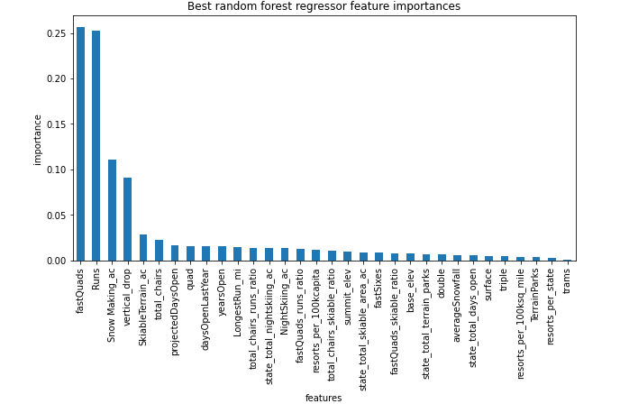

*Figure 1*

The Random Forest Regressor assesses performance using cross-validation with mean and median as hyperparameters for its inputs. Figure 1 indicates that the dominant top four features that people value are Fast-Quad chair lifts, the number of runs, the amount of snow made, and the height of vertical drops. These had the highest positive correlation to ticket prices and should be marketed if ticket prices were to rise. The models that were built for predictive analysis are based around these four features as they are the most determining when thinking about prices.

Currently the price of a Big Mountain Resort adult weekend ticket sits at $81.00 but our predictive model suggests based on how other resorts have priced their tickets that it should be priced at $95.06 with an expected mean absolute error of $10.32. In comparison to other facilities in Montana, BMR is currently underselling their ticket prices. BMR expects 350,000 visitors every season with each visitor staying an average of 5 days.. If the price were to increase by a factor of $14 BMR would increase its seasonal revenue by approximately $24,500,000 which would be sufficient to offset the increase of $1,500,000 in operating costs due to the installation of a new lift chair. However, a drastic increase in price would not be ideal for customer satisfaction so BMR has shortlisted 4 options as alternatives to increase revenue:

1. Permanently closing down up to 10 of the least used runs
2. Increase the vertical drop by adding a run to a point 150 feet lower down but requiring the installation of an additional chair lift to bring skiers back up, without additional snow making coverage
3. Same as number 2, but adding 2 acres of snow making cover
4. Increase the longest run by 0.2 miles to boast 3.5 miles length requiring extra snow making coverage of 4 acres.

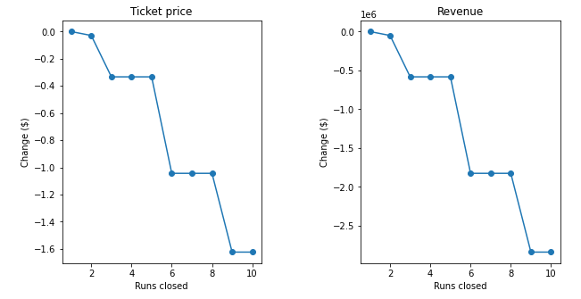

*Figure 2*

Figure 2 shows the relationship of changes to ticket price and revenue when held against the number of runs that closed. The model says that closing 1 run makes no differences. Closing 2 or 3 runs successively reduces support for ticket price and as a result revenue. Closing 4 or 5 runs has the same effects as closing down 3 runs so if BMR chooses to close 3 runs, they might as well close down 5 to further save on operational costs. Increasing closures to 6 or more leads to a drastic drop in the support of ticket prices so it would not be recommended. Some of the other alternatives come with additional operating costs such as adding a new lift and additional snow making coverage. Option 2 and 3 increases support for ticket price by $0.99 which could be expected to amount to $1,724,638 over the season. Both of these options yielded similar events but option 3 would be more costly to execute so the second alternative is recommended. Our predictive model indicated that option 4 was not viable. Adding 0.2 miles to the longest run barely had an impact on ticket prices. The results from the random forest regressor indicated that longest run was not something that people highly valued.